Unit 2 Plan (AP Macroeconomics)

Unit 2: Measurement of Economic Performance 7 Class Sessions 1/23—2/1

Unit 2 Practice Test Due 2/3

Key Concepts in Unit 2

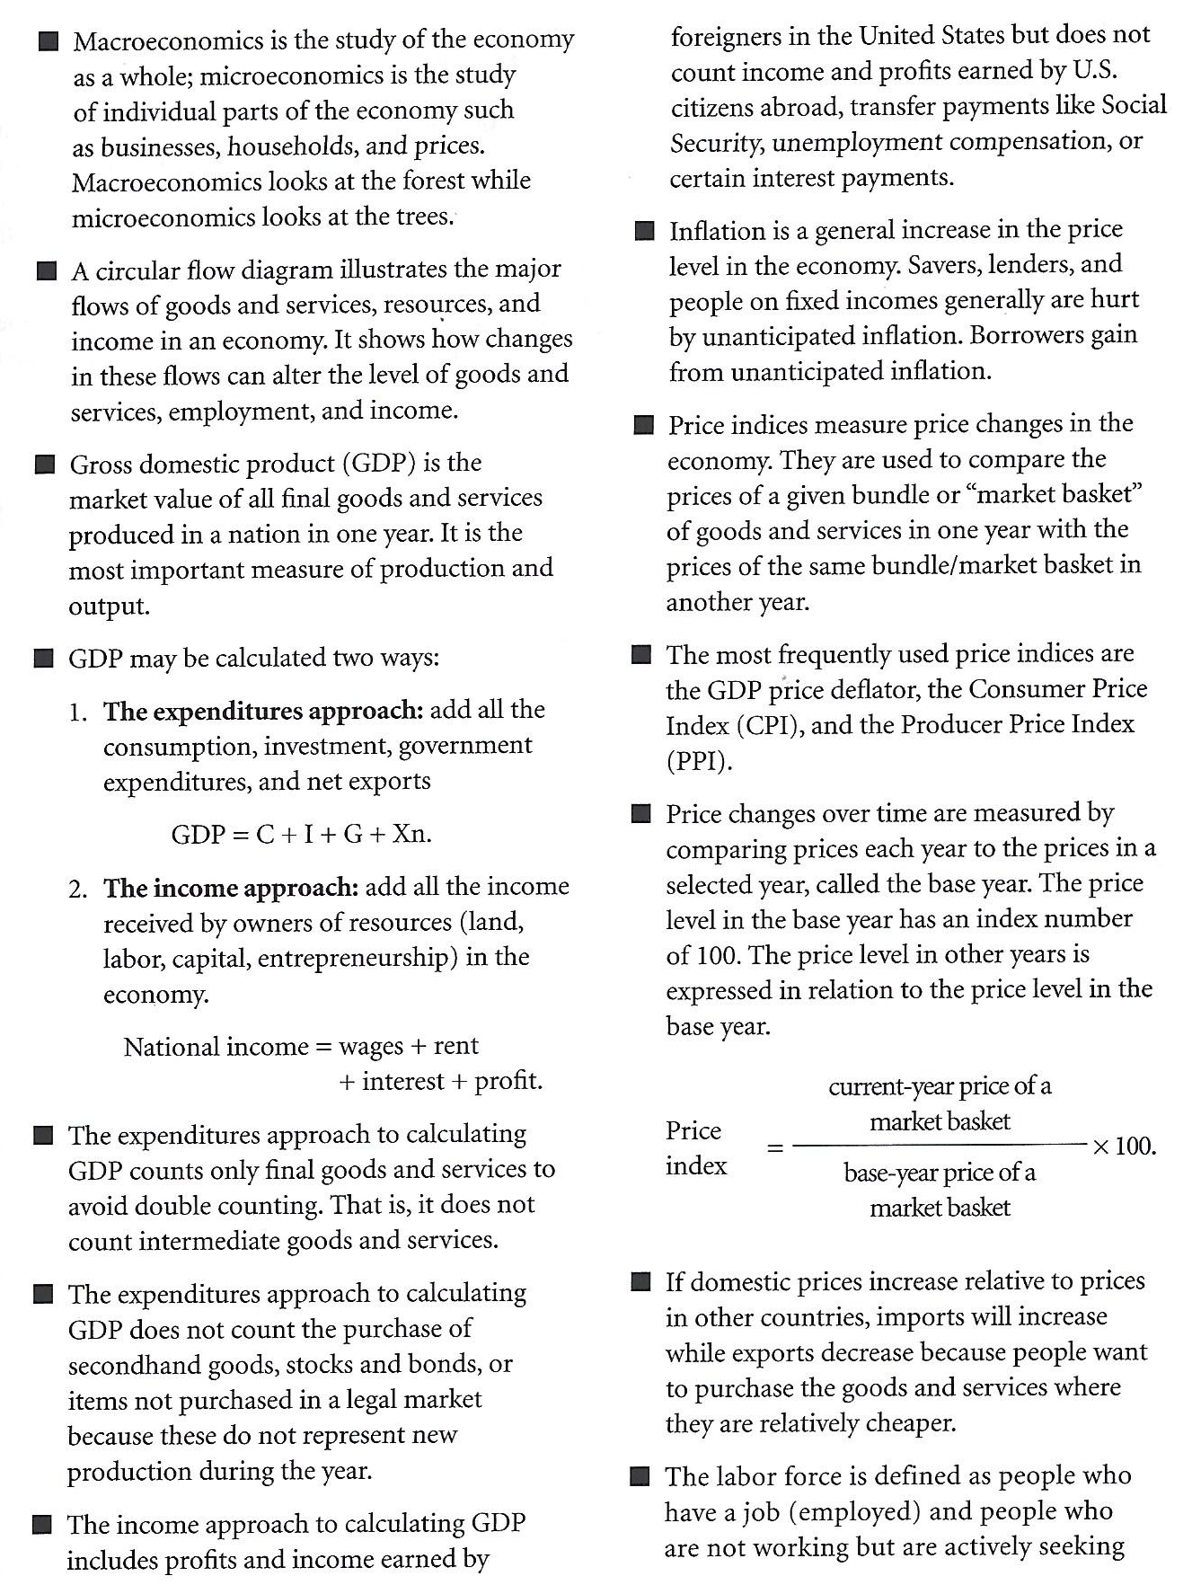

January 23: Circular Flow of Money / What counts in GDP
- Module 10 (Krugman’s Economics for AP)
- Unit 2 Learning Target Packet pp. 3-5
- Turn in: “Definitions and Terms to Know” on Seesaw (photo or PDF is fine)
- Hand out Unit 1 Test form…This is due on January 25th!

January 24: Calculating GDP / Interpreting the Measurement of GDP
DEFINITIONS SHOULD BE FILLED OUT AND POSTED ON SEESAW
- Entrance Ticket: What counts in GDP? (on Socrative)
- Module 11 (Krugman’s Economics for AP)
- Unit 2 Learning Target Packet pp. 6-8
- Finish Unit 1 Take-Home test for tomorrow!

January 25: Types of Inflation / Costs of Inflation / Who is helped or hurt by inflation?
(Block Day) UNIT 1 TAKE-HOME TEST DUE IN CLASS!
- Entrance Ticket: Calculating GDP (on Socrative)
- Module 14 (Krugman’s Economics for AP)
- Unit 2 Learning Target Packet pp. 9-12
- Work on the “Economics in the News” Annotated bibliography

January 27: Price Indicies / The measurement of calculation of inflation
- Entrance Ticket: Who is helped or hurt by inflation? (on Socrative)
- Module 15 (Krugman’s Economics for AP)
- Unit 2 Learning Target Packet pp. 13-14
- Work on the “Economics in the News” Annotated bibliography

January 30: Types of Unemployment / Basics of the Labor Market
FIRST FIVE ARTICLES FOR ANNOTATED BIBLIOGRAPHY DUE TO TURNITIN.COM
- Entrance Ticket: Basics of the labor market (on Socrative)
- Module 12-13 (Krugman’s Economics for AP)
- Unit 2 Learning Target Packet pp. 15-16

January 31: Calculating Unemployment / Assessing the issues with U3-U6 Data from the BLS
- Entrance Ticket: Types of Unemployment (on Socrative)
- Module 12-13 (Krugman’s Economics for AP)
- Unit 2 Learning Target Packet pp. 15-16
- Analysis of Bureau of Labor Statistics Data

February 1: Problems with macroeconomic measurements / “Thinking like a Macroeconomist”
(Block Day)
- Entrance Ticket: Bureau of Labor Statistics measurements (on Socrative)
- Unit 2 Learning Target Packet pp. 17-18

February 3: UNIT 2 TAKE-HOME TEST DUE!

