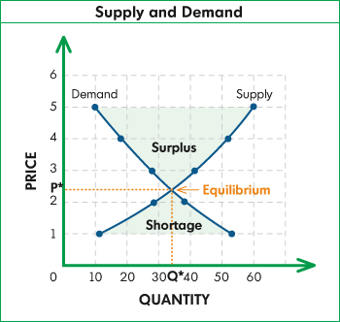

Unit 1 Test will be ___________________________________
Unit 1 Learning Targets
At the completion of this unit students will be able to:
- Apply the concept of opportunity cost to a production possibilities curve
- Define absolute and comparative advantage. Apply them to trading relationships and explain how they inform decisions about specialization
- Identify and apply the law of demand and law of supply
- Demonstrate and explain the difference between a shift in the demand/supply curve and a movement along the demand/supply curve
- Analyze situations to determine if the demand/supply curves are shifting
- Explain why, at prices above or below the equilibrium price, market forces operate to move the price back toward equilibrium price.
- Predict the equilibrium price and quantity if there are changes in demand or supply
- Identify the four phases of the business cycle and the relationship to unemployment and production rates in the economy
- Explain the difference between price changes and inflation/deflation and why price stability is preferred

SHOULD BE FILLED OUT/DEFINED BY: _____________________________________

Key Terms to Define (and learn!)

Scarcity
Microeconomics
Macroeconomics
Trade off
Opportunity cost
Comparative Advantage
Absolute Advantage
Production Possibilities Curve
Supply
Demand
Specialization
Terms of Trade
Recession
Unemployment
Inflation
Subsidy
Marginal Analysis
Efficiency (Allocative v. Productive)

Important Terms and Concepts (Opportunity Cost, PPF/PPC)
Complete after you have watched the videos on opportunity cost / PPF
- Resources used to produce goods and services
- System in which allocation decisions are made in accordance with centralized direction
- Breaking tasks into smaller jobs
- Ability to produce goods less inefficiently than other producers
- Decision on how to divide scarce resources among different uses
- Instruments used to create the goods and services people desire
- Graph of combination of goods that can be produced with available inputs and existing technology
- Goods and services that firms produce
- System in which decisions on resource allocation come from independent decisions of consumers and producers
- Absence of waste
- Forgone value of next best alternative
- Tendency for the opportunity cost of an additional unit of output to rise as production increases
- A decision that best serves the decision maker’s objectives
1. _________ Resources
2. _________ Opportunity Cost
3. _________ Optimal decision
4. _________ Outputs
5. _________ Inputs
6. _________ Production Possibilities Frontier
7. _________ Principle of increasing costs
8. _________ Efficiency
9. _________ Allocation of resources
10. ________ Division of labor
11. ________ Comparative advantage
12. ________ Market system

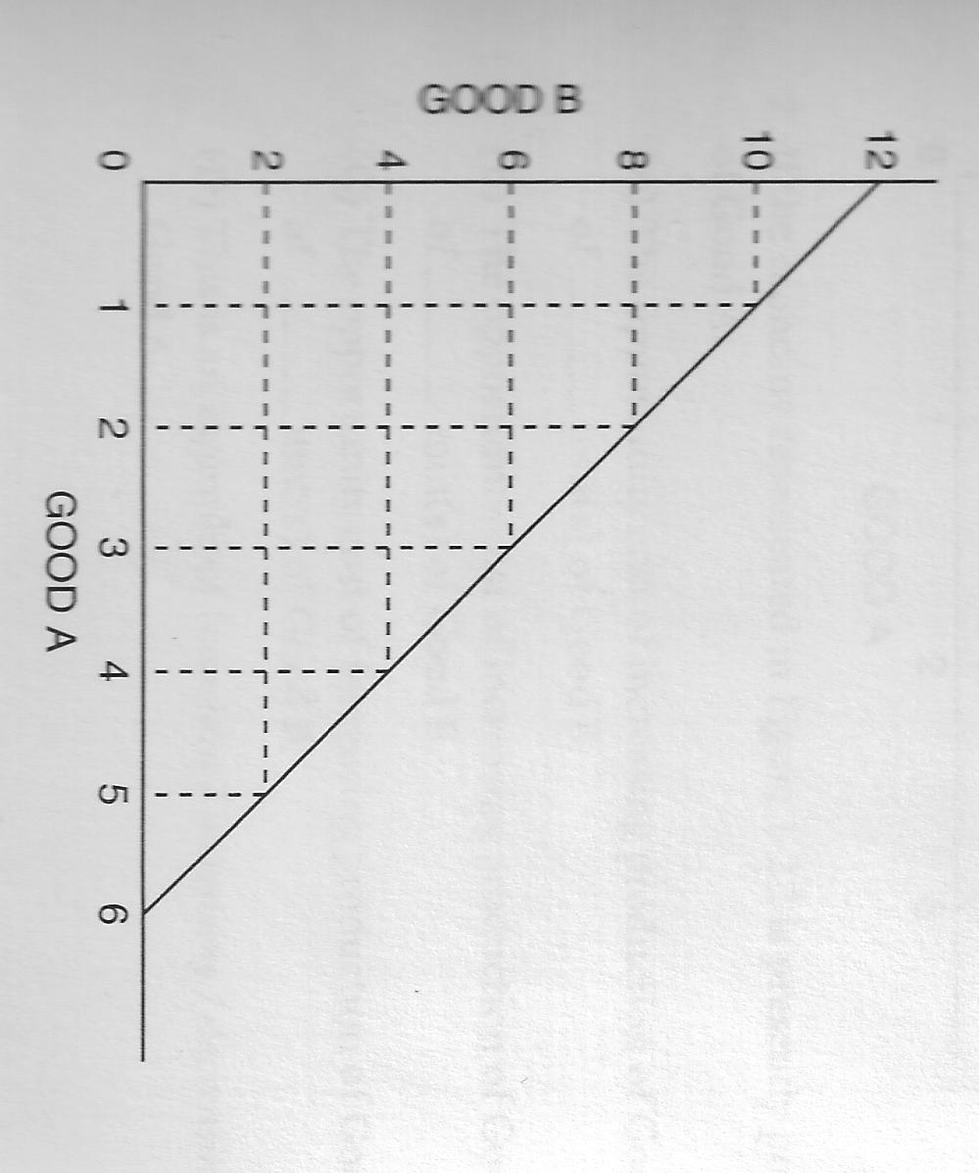
Scarcity, Opportunity Cost, and Production Possibilities Curves

Basic / Linear PPC

1. Assume the economy represented above is presently producing 12 units of Good B and 0 units of Good A:

…If we move from 0 units of A to 1 unit, what is the opportunity cost? ________________________________

…If we move from 1 unit of A to 2 units, what is the opportunity cost? ________________________________

…If we move from 2 units of A to 3 units, what is the opportunity cost? ________________________________

What type of Opportunity cost does this represent? Increasing decreasing constant zero

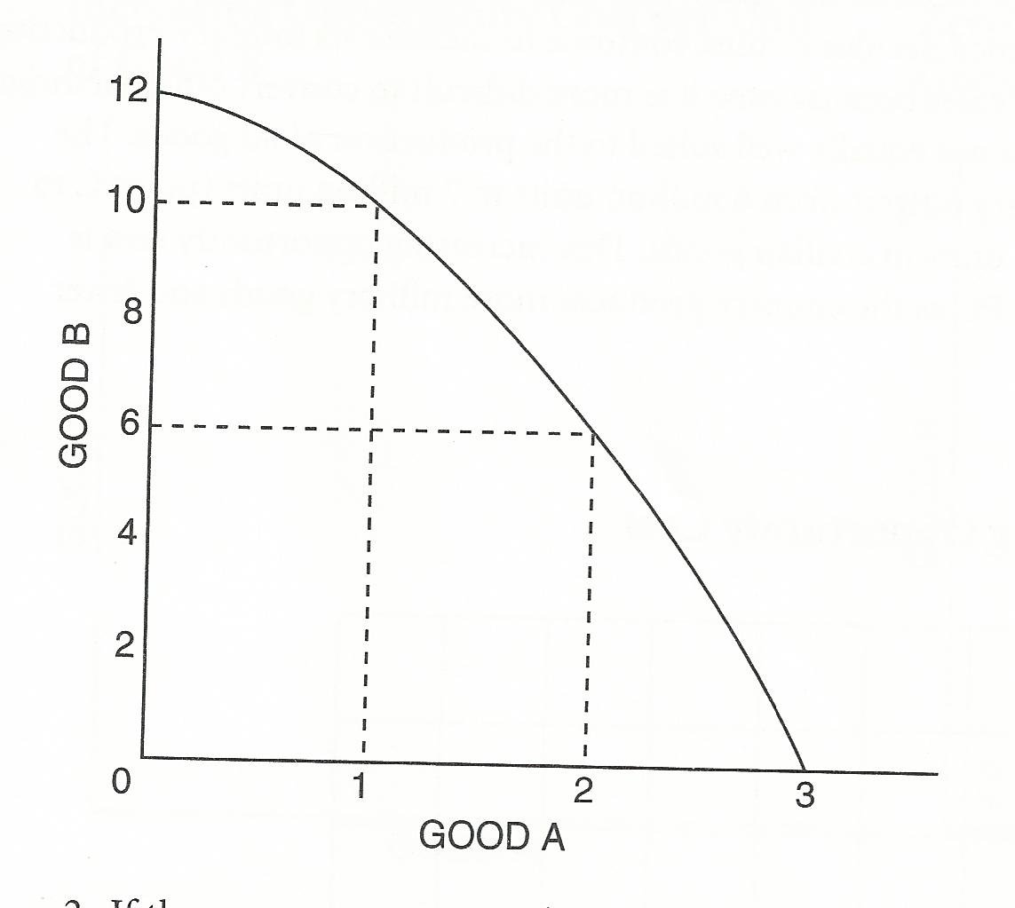
Concave PPC

2. IF the economy represented above is presently producing 12 units of Good B and 0 units of Good A:

…If we move from 0 units of A to 1 unit, what is the opportunity cost? ________________________________

…If we move from 1 unit of A to 2 units, what is the opportunity cost? ________________________________

…If we move from 2 units of A to 3 units, what is the opportunity cost? ________________________________

What type of Opportunity cost does this represent? Increasing decreasing constant zero

Draw the following examples of opportunity cost as a PPF graph…

Good A
Good B
Good A
Good B
Good B

Good A

Constant Opp Cost Increasing Opp Cost Zero Opp Cost
(Per Unit of Good B) (Per Unit of Good B) (Per Unit of Good B)

Definitions…

Capital Goods Consumer Goods

“the guns or butter” decision

Production Possibilities Curve: Capital Goods and Consumer Goods

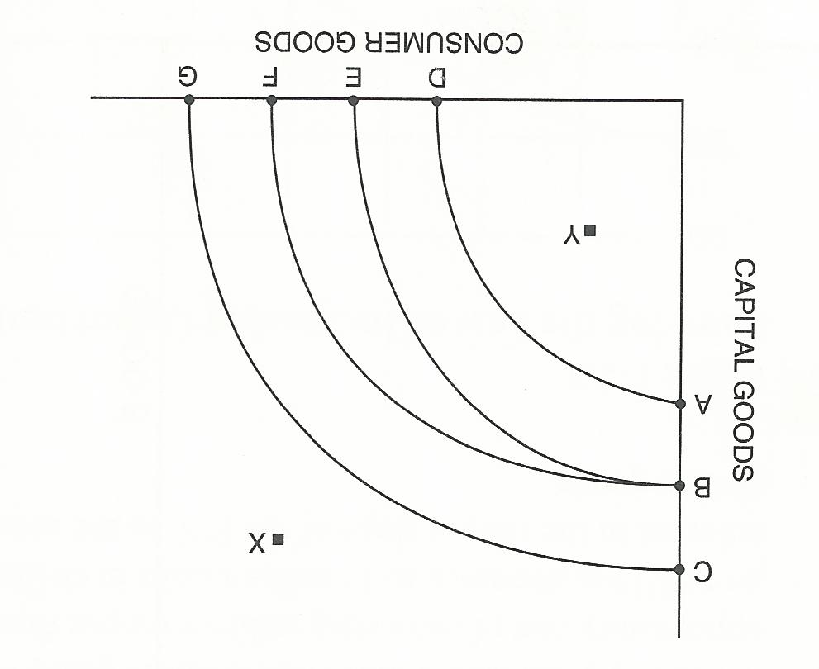

For each question below the economy starts at curve BE!

1. Suppose there is a major technological breakthrough in the consumer-goods industry, and the new technology is widely adopted. Which curve in the diagram would represent the new PPC? (Indicate with the two letters)

__________________________

2. Suppose a new government comes into power and forbids the use of automated machinery and modern production techniques in all industries. Which curve in the diagram would represent the new PPC?

__________________________

3. Suppose massive new sources of oil and coal are found within the economy, and there are major technological innovations in both industries. Which curve in the diagram would represent the new PPC?

__________________________

4. If BE represents a country’s current PPC, what can you say about a point like X?

5. If BE represents a country’s current PPC, what can you say about a point like Y?

PPC: Economic Growth

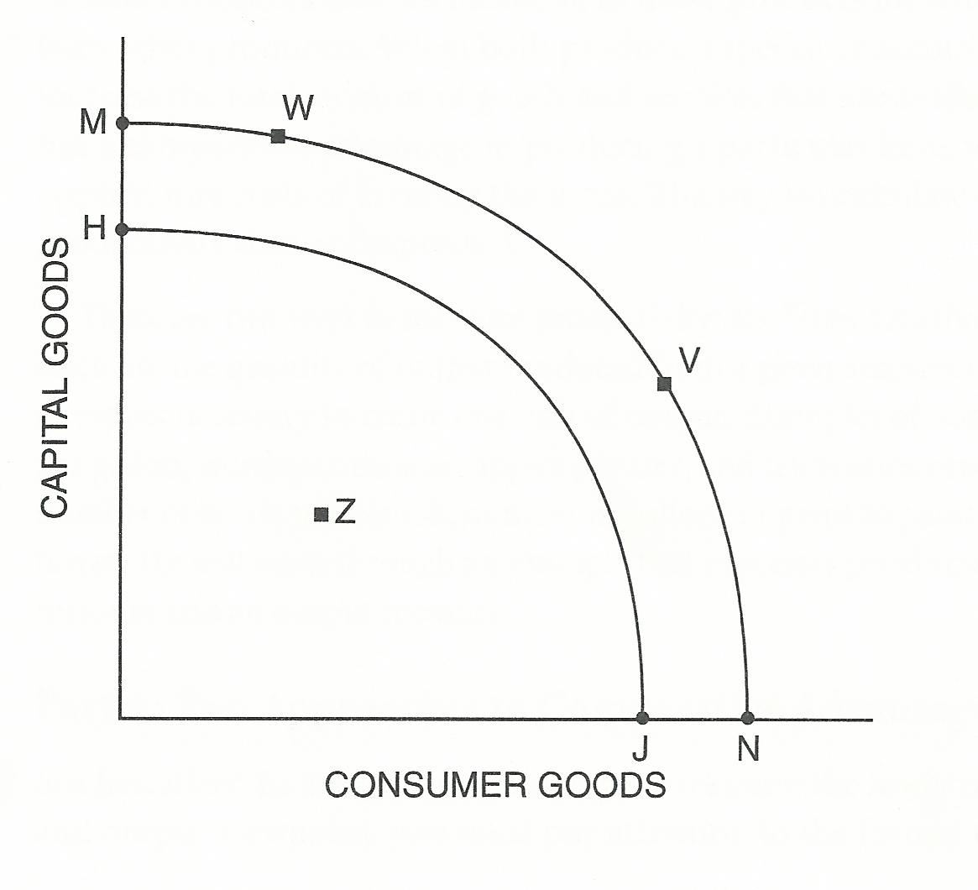

1. What change would cause the PPC to shift from the original curve (HJ) to the new curve (MN)?

2. Under what conditions might an economy be operating at Point Z?

3. Why might a government implement a policy to move the economy from Point V to Point W?

Comparative Advantage
1. Anna and Barry can grow the following amounts of potatoes and cabbage with a week of labor.
 | Potatoes per week | Cabbage per week
Anna | 100 units | 200 units
Barry | 120 units | 150 units

- This is an example of an INPUT problem or an OUTPUT problem?
B. What is the opportunity cost for each producer in making these products?
Anna’s OC of producing a unit of potatoes is ______ units of cabbage.
Barry’s OC of producing a unit of potatoes is ______ units of cabbage.
Anna’s OC of producing a unit of cabbage is _______ units of potatoes.
Barry’s OC of producing a unit of cabbage is _______ units of potatoes.
C. Who has the comparative advantage?
Potatoes ________________ Cabbage __________________
2. Henry and John are fisherman who catch bass and catfish. This chart shows how many of each type of fish they can catch in one day.
 | Bass | Catfish
Henry | 4 bass | 6 catfish
John | 24 bass | 12 catfish

- This is an example of an INPUT problem or an OUTPUT problem?
B. What is the opportunity cost for each producer in making these products?
Henry’s OC of catching one Bass is ______ Catfish.
John’s OC of catching one Bass is ______ Catfish.
Henry’s OC of catching one Catfish is _______ Bass.
John’s OC of catching one Catfish is _______ Bass.
C. Who has the comparative advantage?
Bass ________________ Catfish __________________

3. This chart shows how many days it takes the ABC Corporation and the XYZ Corporation to produce one unit of cars and one unit of planes.
 | Cars | Planes
ABC Corp | 8 days | 10 days
XYZ Corp | 15 days | 12 days

- This is an example of an INPUT problem or an OUTPUT problem?
B. What is the OC for each corporation in producing these goods?
ABC’s OC of producing a unit of cars is _____________ units of planes.
XYZ’s OC of producing a unit of cars is _____________ units of planes
ABC’s OC of producing a unit of planes is ____________ units of cars.
XYZ’s OC of producing a unit of planes is ____________ units of cars.
C. Who has the comparative advantage?
Cars ________________ Planes __________________

4. Here are the numbers of acres needed in India and China to produce 100 bushels of corn or 100 bushels of rice for each month.
 | India | China
Corn | 9 acres | 8 acres
Rice | 3 acres | 2 acres

- This is an example of an INPUT problem or an OUTPUT problem?
B. What is the OC for each country in producing these goods?
India’s OC of growing 100 bushels of corn is ____________ bushels of rice.
China’s OC of growing 100 bushels of corn is ____________ bushels of rice.
India’s OC of growing 100 bushels of rice is ____________ bushels of corn.
China’s OC of growing 100 bushels of rice is ____________ bushels of corn.
C. Who has the comparative advantage?
Corn ________________ Rice __________________
5. This chart shows how many cans of olives and bottles of olive oil can be produced in Zaire and Columbia from one ton of olives.
 | Zaire | Columbia
Olives | 60 cans | 24 cans
Olive Oil | 10 bottles | 8 bottles

- This is an example of an INPUT problem or an OUTPUT problem?
B. What is the OC for each country in producing these goods?
Zaire’s OC of producing 1 can of olives is ____________ bottles of olive oil
Columbia’s OC of producing 1 can of olives is ____________ bottles of olive oil
Zaire’s OC of producing 1 bottle of olive oil is ____________ cans of olives
Columbia’s OC of producing 1 bottle of olive oil is ____________ cans of olives.
C. Who has the comparative advantage?
Olives ________________ Olive oil __________________

6. Here are the numbers of hours needed in Redland and Blueland to produce a unit of televisions and a unit of computers.
 | Televisions | Computers
Redland | 18 hours | 6 hours
Blueland | 16 hours | 4 hours

- This is an example of an INPUT problem or an OUTPUT problem?
B. What is the OC for each country in producing these goods?
Redland’s OC of producing 1 unit of televisions is ______________ units of computers
Blueland’s OC of producing 1 unit of televisions is ______________ units of computers
Redland’s OC of producing 1 unit of computers is ______________ units of televisions.
Blueland’s OC of producing 1 unit of computers is ______________ units of televisions
C. Who has the comparative advantage?
Televisions ________________ Computers __________________

Important Terms and Concepts (Supply and Demand)
Complete after you have watched the videos on supply and demand basics
1. _________ Invisible hand
- Observation that in a free market, price tends to a level where quantity supplied equals quantity demanded
- Legal minimum price that may be charged
- Graph depicting how quantity demanded changes as price changes
- Change in price causing a change in quantity supplied or demanded
- Number of units consumers want to buy at a given price
- Individual actions to pursue self-interest in a market system promote social well-being
- Table depicting how the quantity demanded changes as price changes
- Situation in which there are no inherent forces producing change
- Table depicting how quantity supplied changes as price changes
- Legal maximum price that may be charged
- Number of units producers want to sell at a given prices
- Table depicting the changes in both quantity demanded and quantity supplied as price changes
- Change in a variable other than price that affects quantity demanded
- Excess of quantity supplied over quantity demanded
- Graph depicting the changes in both quantity supplied and quantity demanded as price changes
- Excess quantity demanded over quantity supplied
- Graph depicting how quantity supplied changes as price changes
2. _________ Quantity Demanded
3. _________ Demand Schedule
4. _________ Demand Curve
5. _________ Shift in demand curve
6. _________ Quantity Supplied
7. _________ Supply Schedule
8. _________ Supply Curve
9. _________ Supply-Demand Diagram
10. ________ Shortage
11. ________ Surplus
12. ________ Equilibrium
13. ________ Law of supply and demand
14. ________ Price ceiling
15. ________ Price floor

Demand: Do you get it?
Test your understanding by answering the following questions…

1. All other things held constant, which of the following would NOT cause a change in the demand (shift in the demand curve) for motorcycles?
a. a decrease in consumer incomes
b. a decrease in the price of motorcycles
c. an increase in the price of bicycles
d. an increase in people’s tastes and preferences for motorcycles.

2. “Rising oil prices have caused a sharp decrease in the demand for oil”. Speaking precisely, and using terms as economists define them, choose the statement that best describes this quotation.
a. the quotation is correct: an increase in price causes an increase in demand
b. the quotation is incorrect: an increase in price causes an increase in demand, not a decrease in demand.
c. the quotation is incorrect: an increase in the price causes a decrease in the quantity demanded, not an a decrease in demand.
d. the quotation is incorrect: an increase in prices causes an increase in the quantity demanded, not a decrease in demand.

3. “As the price of domestic automobiles has risen, customers have found foreign autos to be a better bargain. Consequently, domestic auto sales have been decreasing, and foreign auto sales have been increasing.” Using only the information in this quotation and assuming everything else remains constant, which of the following best describes this statement?
a. A shift in the demand curves for both domestic and foreign automobiles
b. A movement along the demand curve for both foreign and domestic automobiles
c. A movement along the demand curve for domestic autos, and a shift in the demand curve for foreign autos
d. A shift in the demand curve for domestic autos, and a movement along the demand curve for foreign autos
Supply: Do you get it?
Test your understanding by answering the following questions…

1. All other things held constant, which of the following would NOT cause a change in the supply of beef?
a. A decrease in the price of beef
b. A decrease in the price of cattle feed
c. An increase in the price of cattle feed
d. An increase in the cost of transporting cattle to market

2. “Falling oil prices have caused a sharp decrease in the supply of oil.” Speaking precisely, and using terms as economists define them, choose the statement that best describes the quotation.
a. the quotation is correct: a decrease in price causes a decrease in supply
b. the quotation is incorrect: a decrease in price causes an increase in supply, not a decrease in supply
c. the quotation is incorrect: a decrease in price causes an increase in the quantity supplied, not a decrease in supply.
d. the quotation is incorrect: a decrease in price causes a decrease in the quantity supplied, not a decrease in supply.

Learning Prep: Price controls (Ceilings and floors)
The following graph shows the market for DVDs. Complete the table below to examine the impact of alternative price ceilings and price floors on the Q_{d} and the Q_{s}. What conclusion can you draw about when ceilings and floors will affect market outcomes.
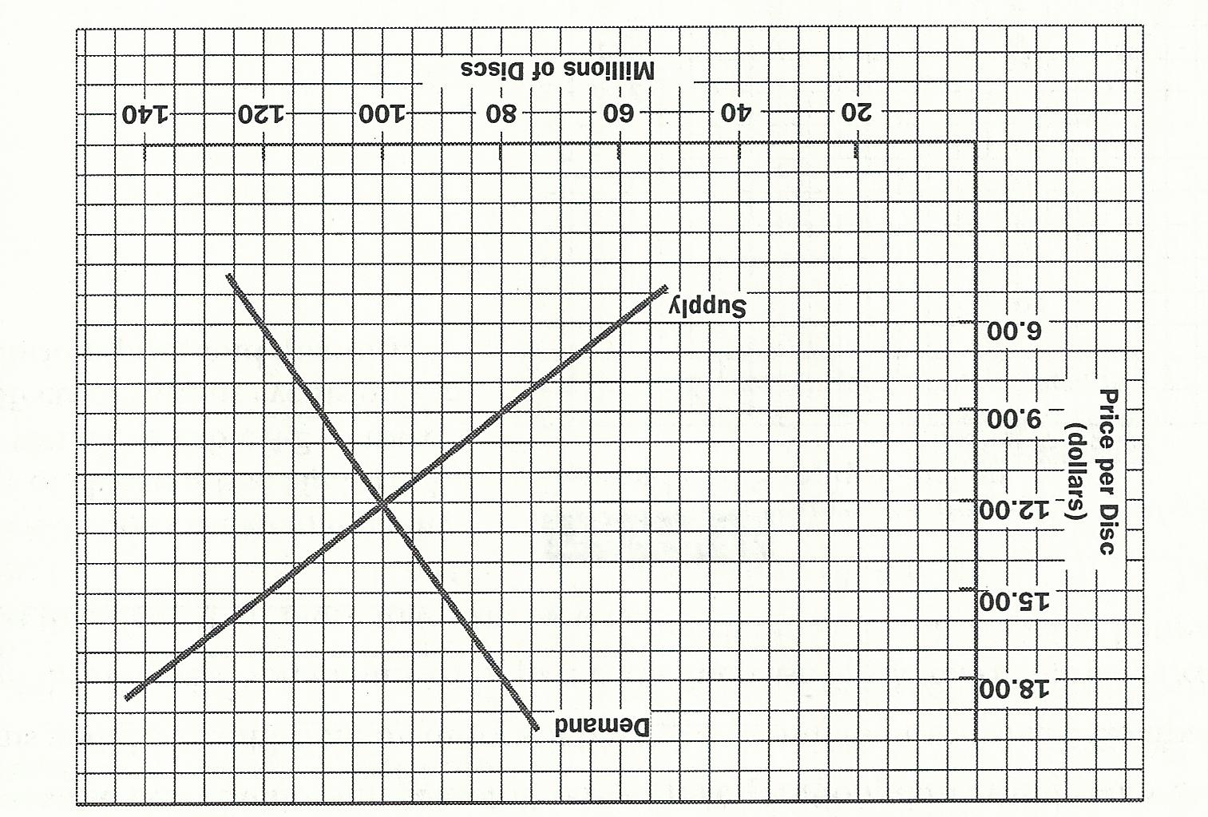

 | Quantity Demanded | Quantity Supplied | Shortage or Surplus or Equilibrium
Price ceiling = $18
Price ceiling = $9
Price floor = $15
Price floor = $6

Factors that shift demand… KNOW THIS CHART!

Shifts in Demand: Impact of events on Demand for US-Made Autos
Headline | Will consumers buy more of less US autos? | Is there a change in demand (ΔD) or a change in quantity demanded (ΔQ_{D})? | Does the Demand curve for US autos shift to the right or left or not shift?
- Consumers’ income drops | More / Less | ΔD / ΔQ_{D} | Right / Left / No shift
- Millions of Immigrants Enter the US | More / Less | ΔD / ΔQ_{D} | Right / Left / No shift
- Price of Foreign Autos Drop | More / Less | ΔD / ΔQ_{D} | Right / Left / No shift
- Major Cities add inexpensive bus lines | More / Less | ΔD / ΔQ_{D} | Right / Left / No shift
- Price of US Autos rises | More / Less | ΔD / ΔQ_{D} | Right / Left / No shift
- Price of US Autos expected to rise soon | More / Less | ΔD / ΔQ_{D} | Right / Left / No shift
- Families look forward to summer vacations | More / Less | ΔD / ΔQ_{D} | Right / Left / No shift
- US auto firms launch effective ad campaigns | More / Less | ΔD / ΔQ_{D} | Right / Left / No shift

Indicate in the chart the reasons for change in Demand for US Autos (given the headlines above)

 | Headline Number…
Reason | 1 | 2 | 3 | 4 | 5 | 6 | 7 | 8
A change in consumer expectations
A change in consumer tastes
A change in the number of consumers in the market
A change in income
A change in the price of a substitute good
A change in the price of a complementary good

Factors that shift supply… KNOW THIS CHART Too!

Shifts in Supply: Impact of events on supply of US-made autos

Headline | Should US auto firms produce more or less? | Is there a change in supply (ΔS) or a change in quantity supplied (ΔQ_{S})? | Does the supply curve of cars shift to the right or left or no shift?
- Auto workers’ Union Agrees to wage cuts | More / Less | ΔS / ΔQ_{S} | Right / Left / No shift
- New robot technology increases efficiency | More / Less | ΔS / ΔQ_{S} | Right / Left / No shift
- Price of US Cars increases | More / Less | ΔS / ΔQ_{S} | Right / Left / No shift
- Nationwide Auto workers strike begins | More / Less | ΔS / ΔQ_{S} | Right / Left / No shift
- Cost of Steel decreases | More / Less | ΔS / ΔQ_{S} | Right / Left / No shift
- Major auto producer goes out of business | More / Less | ΔS / ΔQ_{S} | Right / Left / No shift
- Buyers reject New car models | More / Less | ΔS / ΔQ_{S} | Right / Left / No shift
- Government gives car producers a subsidy | More / Less | ΔS / ΔQ_{S} | Right / Left / No shift

Indicate in the chart the reasons for change in Demand for US Autos (given the headlines above)

 | Headline Number…
Reason | 1 | 2 | 3 | 4 | 5 | 6 | 7 | 8
A change in costs of inputs to production process
A change in technology
A change in the number of producers in the market
Government policies

Learning Prep:

This figure shows the demand and supply of chicken. Use the figure while you fill in the table for use in class. Trace the effects of various events on the equilibrium price and quantity.
Market: Chicken
Event | Which curve shifts? | Is the direction left or right? | Does Eq price rise or fall? | Does Eq Qty rise or fall?  P  Q  D  S
A sharp increase in the price of beef leads many consumers to switch from beef to chicken.

A bumper grain crop cuts the cost of chicken feed in half.

Extraordinarily cold weather destroys a significant number of chickens.

A sudden interest in Eastern religions converts many chicken eaters to vegetarians.

Graphing the changes in Supply and Demand

The supply and demand for Jelly Beans
(Fill in the answers with the graph that applies to each situation)

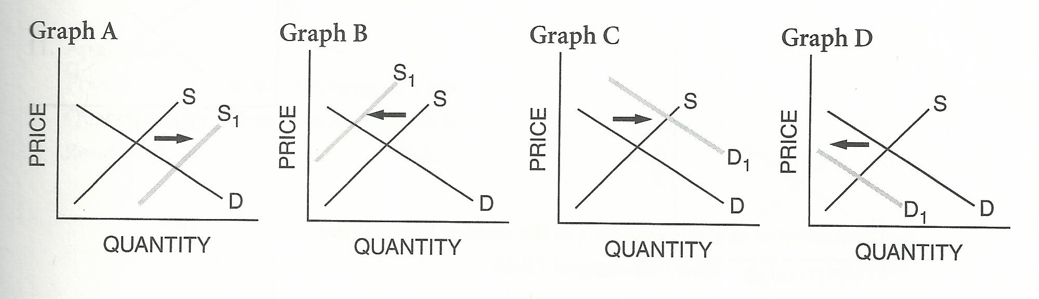

1. The prices of sugar, a key ingredient in producing jelly beans, increases. __________________________

2. The price of bubble gum, a close substitute for jellybeans, increases. __________________________

3. A machine is invented that makes jellybeans at a lower cost. __________________________

4. The government places a tax on foreign jellybeans, which have a considerable share of the market. _____________

5. The price of soda, a complementary good for jellybeans, increases. __________________________

6. Widespread prosperity allows people to buy more jellybeans. __________________________

Apples, Pears, and Pies

Connecticut ships large amounts of apples to all parts of the US by rail. Indicate the effects on prices and quantity for each situation, and complete the graphs below, showing how a hurricane destroys apples before they are picked in Connecticut might affect the price and quantity of each commodity. Be ready to explain your reasoning…

1. Apples in Boston
P
Q
D
S

Price: Rises Unchanged Falls
Quantity: Rises Unchanged Falls

Reason:

2. Land devoted to apple orchards in the state of Washington
P
Q
D
S

Price: Rises Unchanged Falls
Quantity: Rises Unchanged Falls

Reason:

3. Apples grown in the state of Washington
P
Q
D
S

Price: Rises Unchanged Falls
Quantity: Rises Unchanged Falls

Reason:

Continued on next page

4. Pears
P
Q
D
S

Price: Rises Unchanged Falls
Quantity: Rises Unchanged Falls

Reason:

5. Apple pies
P
Q
D
S

Price: Rises Unchanged Falls
Quantity: Rises Unchanged Falls

Reason:

Extra Learning Practice: Shifting Supply and Demand

The following questions refer to a group of related markets in the US during a given time period. Assume that the markets are perfectly competitive (no forces at play other than price) and that the supply and demand model is completely applicable. Trace the effects of the assumed change, OTHER THINGS CONSTANT. Work your way from left to right. Shift only one curve in each market.

Assume that a new fertilizer dramatically increases the amount of wheat that can be harvested with no additional labor or machinery. Also assume that this fertilizer does not affect potato farming and that people are satisfied to eat either bread made from wheat flour or potatoes.
P
Q
S
D
P
Q
S
D
P
Q
S
D
P
Q
S
D
Wheat
Potatoes
Wheat Harvesting Machinery
Demand

Supply

Equilibrium Price

Equilibrium Quantity
↑ = ↓
↑ = ↓
↑ = ↓
↑ = ↓
↑ = ↓
↑ = ↓
↑ = ↓
↑ = ↓
↑ = ↓
↑ = ↓
↑ = ↓
↑ = ↓
↑ = ↓
↑ = ↓
↑ = ↓
↑ = ↓
Bread

See next page for another practice problem set

Assume beef and pork are perfect substitutes. The price of pork rises dramatically. Ketchup is a complement to beef; mustard is a complement to pork.
P
Q
S
D
P
Q
S
D
P
Q
S
D
P
Q
S
D
Beef
Ketchup
Mustard
Demand

Supply

Equilibrium Price

Equilibrium Quantity
↑ = ↓
↑ = ↓
↑ = ↓
↑ = ↓
↑ = ↓
↑ = ↓
↑ = ↓
↑ = ↓
↑ = ↓
↑ = ↓
↑ = ↓
↑ = ↓
↑ = ↓
↑ = ↓
↑ = ↓
↑ = ↓
Feed for cattle

The Business Cycle and Macroeconomics

Draw the business cycle and label the following: Peak Recession trough recovery
Double Dip Recession Depression

Draw the business cycle as a function of the unemployment rate…

Free Response question practice…

Things to note on writing the FRQ’s for the AP Macroeconomics exam

JTFJ | “Just the Facts Jack/Jane” … don’t write a thesis, intro, or 5 paragraph essay. This is economics and it requires a concise answer.
ADQ | “Answer the D--- Question!”… Much like above, don’t go into a deep analysis if it is not asked for. Don’t answer other questions in the same question. Don’t use this as an opportunity to show off what you know. If you don’t know the answer or how to get to the answer don’t spend time explaining the concepts “around” the answer. They just want an answer…don’t B--- S--- your way on the question.
Multiple parts | Questions are in multiple parts and points are awarded for each part independently. You should attempt to answer ALL parts. Even if a later answer depends on a previous answer you might still get credit even if the previous answer was wrong. If you follow the logic they might give you points.  Use the same outline or letters from the question as written. It helps the faculty scorer IMMENSELY!
SICE | Show means to diagram or graph a macroeconomic effect. It is possible to get partial points, so always take a shot at these and be sure to label them fastidiously.  Identify usually means just that: Identify the result of something happening. A short, direct response is expected (and desired). Example: 'Unemployment will rise.' If the question does not explicitly ask for explanation, don't bother writing one.  Calculate usually will mean to apply a formula that you (hopefully) have mastered with practice. Keep a running page in your notebook of the formulas we use… there will be A LOT of them.  Explain should leap off the page when you see it in an FRQ. That means you are expected to both indicate what will happen and offer an explanation as to why or how it happens.
Master the graphs / models | You should always be thinking of the models when answering the questions in both the MC and FRQ sections. Know how to label ALL of the parts and show your logic clearly on the graph. Sometimes an answer on the FRQ will not require any words! A well constructed and labeled graph will do the trick.

The Production Possibilities Curve model FRQ Due in class on __________________________

- Refer to the graph below. Assume that the country is producing at point C.
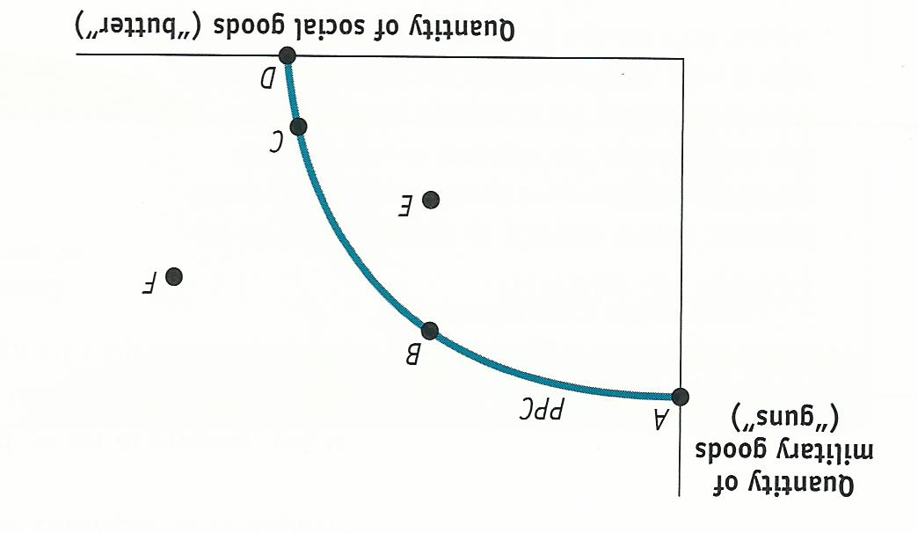

- Does this country’s production possibilities curve exhibit increasing opportunity costs? Explain.
- If this country were to go to war, the most likely move would be from point C to which point? Explain.
- If the economy entered into a recession, the country would move from point C to which point? Explain.

- Assume that an economy can choose between producing food and producing shelter at a constant opportunity cost. Draw a correctly labeled production possibilities curve for the economy. On your graph:
  - Use the letter E to label one of the points that is efficient in production
  - Use the letter U to label one of the points at which there might be unemployment.
  - Use the letter I to label one of the points that is not feasible

Comparative Advantage and Trade DUE in class on __________________________

- Refer to the graph below to answer the following questions.

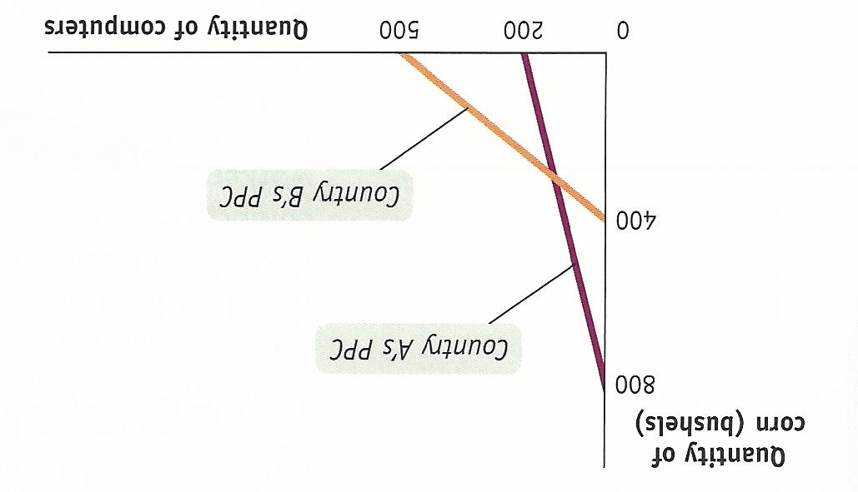

- What is the opportunity cost of a bushel of corn in each country?
- Which country has absolute advantage in computer production? Explain
- Which country has a comparative advantage in corn production? Explain
- If each country specializes, what good will Country B import? Explain.
- What is the minimum price Country A will accept to export corn to Country B? Explain.

Price Ceilings and Price Floors Due in class on __________________________
- Refer to the graph below to answer the following questions.

(Nota Bene: S_{l} = the supply of labor or workers; D_{l}= the demand for labor or number of jobs)
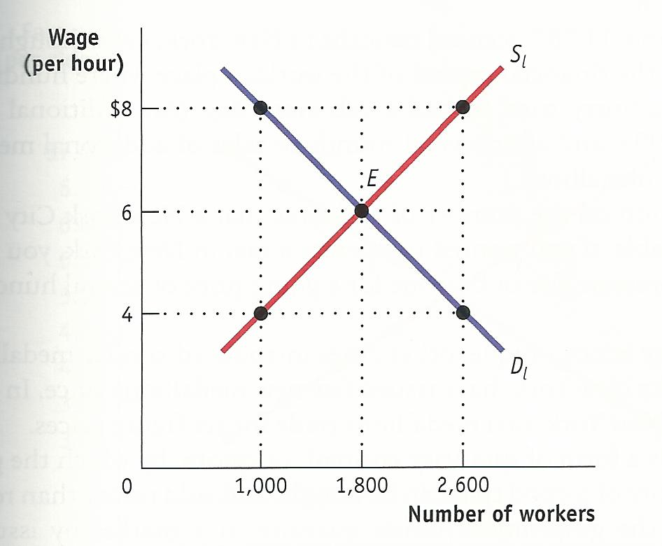

- What are the equilibrium wage and quantity of workers in this market?
- For it to be effective, where would the government have to set a minimum wage?
- If the government set a minimum wage at $8,
- How many workers would supply their labor?
- How many workers would be hired?
- How many workers would want to work that did NOT want to work for the equilibrium wage?
- How many previously employed workers would no longer have a job?

Business Cycle and Macroeconomics FRQ DUE in class on __________________________

- Define an expansion and economic growth, and explain the difference between the two concepts. (3 points)

- Define inflation, and explain why an increase in the price of donuts does not indicate that inflation has occurred. (2 points)

