It’s one thing to think you are a “Republican” or “Democrat”, but it’s another thing to know why! These political ideology assessments are designed to allow you to explore your answers to the questions facing our country today. Your results are an important step in understanding where you “fit” on the political spectrum of the US.
Your task is to work through these assessments and document your results. Each survey has its limitations and it is important to realize that these are only tools to help us identify where we stand on issues facing us today.

BEFORE TAKING THESE INVENTORIES…
I am a _______________________________________ (insert political leanings here!)

because I believe... (note at least four ideas/views/issues)

AFTER TAKING THE INVENTORIES…
These inventories say that I am most likely to be described as _______________________________________________.

How did these validate what you already thought? How did they challenge your ideas about your political beliefs?

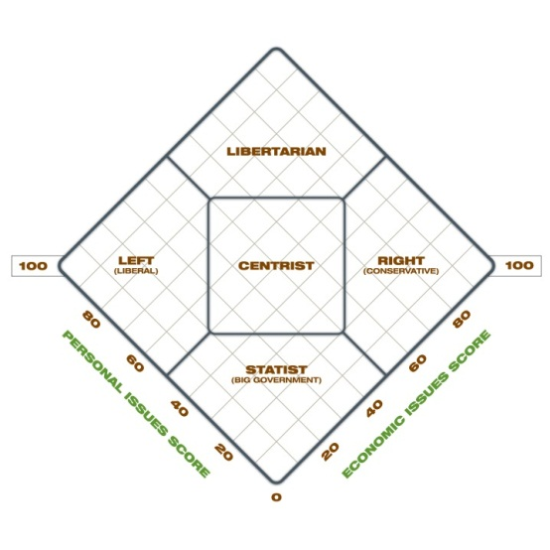
“World’s Smallest Political Quiz”
http://www.theadvocates.org/quiz/quiz.php

Pew Research Center Political Ideology
http://www.people-press.org/typology/quiz/
What is your “ideology” as noted here:

Where does this fit in your understanding of your own viewpoints?

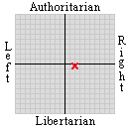Political Spectrum Quiz
http://gotoquiz.com/politics/political-spectrum-quiz.html
\

Isidewith.com
Go to www.isidewith.com and take the political inventory. Note where you connect with each political party AND what issues you are most similar to them in.
…Are you solidly one political party, or do you have leanings in many different directions? What was your ideology?
…What were your “political themes”?
Populism/Elitism Small Government/Big Government Tough/Tender
Equality/Liberty Traditional/Progressive
…What did you learn when looking at the map of the US and ideology? Are you among “friends”? Are you an “ideological island”?

