AP GaP Summer Reading Assignment (Part 2)
This reading assignment is designed to help you dive into some of the major issues defining our political landscape in this country. Far too often we simply know the basics of politics and political participation and we know precious little about the deep issues dividing us or the realities of the political machine. This reading assignment is designed to promote learning and exploration serving as a foundation for our study of government.
Your task is three-fold:
- Choose (and read!) a book from the list on the next few pages. You will only have to read ONE of the books, although all of them are good and engaging.
- Complete the “Book Review” assignment included at the end of this packet.
- Submit this book review to Turnitin.com. The submission codes are available on my course website
We are asking all AP Government and Politics students to complete this reading assignment in order to help you become an expert in an area of analysis for the course. You will serve as a resource for the class in our discussions as we get through various units.
This is due on the 2nd day of class.

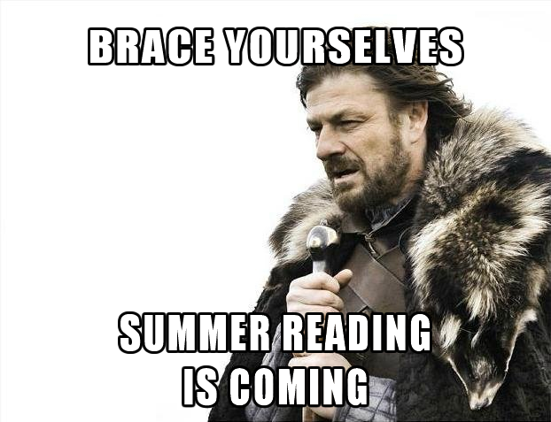

Book | Review | Availability
Hardball: How politics is played, told by one who knows the game (Revised and updated edition), By Chris Matthews  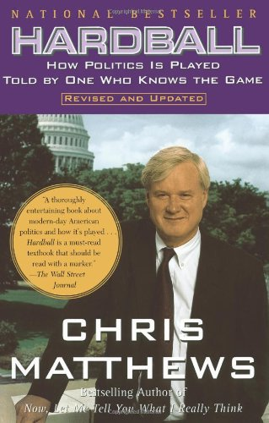 | Hardball, first published in 1988, is like a modern version of Machiavelli's The Prince, only much more richly illustrated, with anecdotes drawn from talk-show host Chris Matthews's stint as a congressional staffer (where he worked for, among others, renowned Speaker of the House Tip O'Neill). Discussing such basic principles as "It's not who you know; it's who you get to know" and "Don't get mad, don't get even--get ahead," Matthews not only dishes out choice Washington insider info, he has over the years inspired many readers to apply his principles for political success to their own professional lives. | Johnson County Library  Or  Amazon.com
The Nine: Inside the Secret World of the Supreme Court, By Jeffrey Toobin  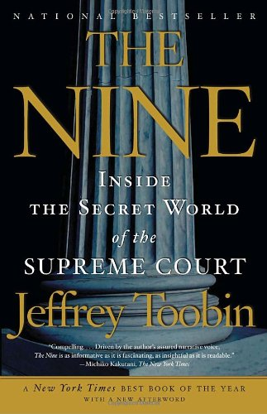 | The Nine is a welcome addition to the spate of recent Supreme Court histories (see Jan Crawford Greenburg's Supreme Conflict, ***1/2 May/June 2007). Informative and authoritative, Jeffrey Toobin's account draws on exclusive interviews with the principals (one critic cited a possible breach of secrecy) and offers colorful anecdotes about the members of the Court. The most important parts of the book explore Sandra Day O'Connor's critical swing votes, Clinton's impeachment hearings, and the Court's role in Bush v. Gore. "The tragedy," Toobin concludes, "was not that it led to Bush's victory, but the inept and unsavory manner that the justices exercised their power." Only David J. Garrow, a Supreme Court historian, faulted Toobin's "debatable opinions" and disdain for various justices. Well written, though chronologically disjointed, The Nine is, overall, a timely and important examination of the Court's past-and its future. | Johnson County Library  Or  Amazon.com
The Victory Lab: The Secret Science of Winning Campaigns, By Sasha Issenberg  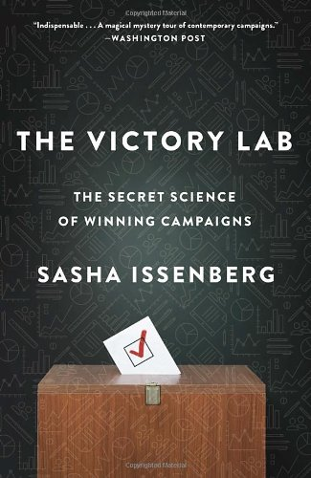 | From political reporter Issenberg comes this very interesting look at the way political consultants and professional vote-getters manipulate people into casting their votes for certain candidates. Although the field has seen some serious innovations over the years—computer models, highly detailed research tools, the use of cutting-edge behavioral psychology to predict how voters will mark their ballots, and more—it’s not a new endeavor. As far back as the 1920s, people like political scientist Harold Foote Gosnell, frustrated by his profession’s inability to explain why people voted the way they did, began looking for new tools to understand and predict voter behavior. By the mid–1940s, social psychologist Angus Campbell was developing “the first systematic effort to explain how presidential elections were decided,” including a massive survey that was the forerunner of the American National Election Studies, a key tool in a field that, today, is a $6 billion-a-year industry. Given its lively subject matter, its equally lively prose, and its timely release—it will hit the shelves two months before Americans go to the polls—this is pretty much guaranteed to generate high interest among readers. --David Pitt --This text refers to an out of print or unavailable edition of this title. | Johnson County Library  Or  Amazon.com
The Big Sort: Why the Clustering of Like-Minded America is Tearing Us Apart, by Bill Bishop | How did zip codes become as useful to political activists as to mail carriers? In the relatively new cultural dynamics of political segregation, Bishop discerns a troubling transformation of American life. Complex and surprising, the story of that transformation will confound readers who suppose that recent decades have made American society both more diverse and more tolerant. Pinpointing 1965 as the year when events in Vietnam, Washington, and Watts delivered body blows to traditional social institutions, Bishop recounts how Americans who had severed ties to community, faith, and family forged new affiliations based on lifestyle preferences. The resulting social realignment has segmented the nation into groupthink communities, fostering political smugness and polarization. The much-noted cartography of Red and Blue states, as Bishop shows, actually distorts the reality of a deeply Blue archipelago of urban islands surrounded by a starkly Red rural sea. Bishop worries about the future of democratic discourse as more and more Americans live, work, and worship surrounded by people who echo their own views. A raft of social-science research underscores the growing difficulty of bipartisan compromise in a balkanized country where politicians win office by satisfying their most radical constituents. A book posing hard questions for readers across the political spectrum. | Johnson County Library  Or  Amazon.com
The Disappearing Center: Engaged Citizens, Polarization, and American Democracy, By Alan Abramowitz  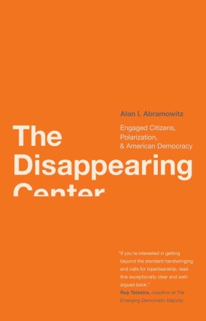 | While many Americans worry over the rise of partisan politics, Emory University political science professor Abramowitz (Voice of the People) finds reason to celebrate: the increasing ideological divide, he argues, has engaged more people while making the stakes in elections more clear, resulting in dramatically higher voter turnout (the 2008 election had the highest turnout "in more than four decades") and a populace that's more politically involved-whether campaigning directly, speaking with friends, contributing money or simply putting up yard signs. Statistics show that the "proportion of pure independents in the electorate has been declining since 1970"; party loyalty today is based not on social group identification (as in FDR's "New Deal Coalition") but ideological beliefs, creating more disciplined Republican and Democratic voting blocs. Abramowitz admits that this can become paralyzing in U.S. democracy (as opposed to parliamentary democracies) when the executive and legislative branches are controlled by different parties, making bipartisan cooperation not just unlikely, but politically damaging, and giving those few moderates who remain outsized importance. Abramowitz bolsters his thought-provoking conclusions with 67 tables and charts. | Johnson County Library  Or  Amazon.com
The Party is Over: How Republicans Went Crazy, Democrats Became Useless, and the Middle Class Got Shafted, By Mike Lofgren  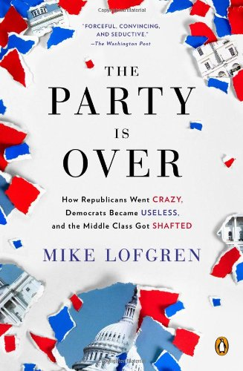 | “Lofgren’s ideas are trenchant and far-reaching. . . . With the feel of a long-repressed confession and the authority of an insider’s testimony, like the anti-war views of a decorated infantry officer . . . he writes about how the Republican party took advantage of a profoundly ignorant electorate, an easily conned and distracted media, and a cowed Democratic Party to press the ideological struggle in spite of the deep unpopularity of many of its positions.”  —George Packer, The New Yorker  “A scrupulously bipartisan diagnosis of the sick state of American politics and governance . . . Lofgren devotes close attention to budget issues rarely accorded so much detail in garden-variety op-ed warfare. Sustaining his original thesis well beyond Internet-browsing attention span, Lofgren has crafted an angry but clear-sighted argument that may not sit well at family reunions or dinner parties, but deserves attention.”  —Publishers Weekly | Johnson County Library  OR  Amazon.com
It’s Even Worse Than it Looks: How the American Constitutional System Collieded with the New Politics of Extremism, By Thomas Mann and Norman Ornstein  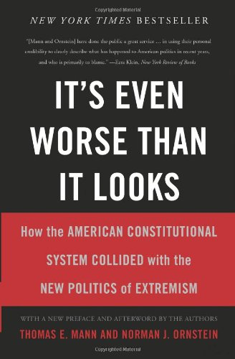 | Hyperpartisanship is as old as American democracy. But now, acrimony is not confined to a moment; it’s a permanent state of affairs and has seeped into every part of the political process. Identifying the overriding problems that have led Congress—and the United States—to the brink of institutional collapse, It’s Even Worse Than It Looks profoundly altered the debate about why America’s government has become so dysfunctional. Through a new preface and afterword, Thomas Mann and Norman Ornstein bring the story forward, examining the 2012 presidential campaign and exploring the prospects of a less dysfunctional government. As provocative and controversial as ever, It’s Even Worse Than It Looks will continue to set the terms of our political debate in the years to come. | Johnson County Library  Or  Amazon.com
Winner-Take-All Politics: How Washington made the rich richer, and turned its back on the middle class, By Jacob Hacker  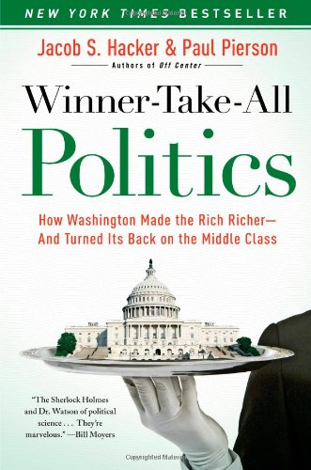 | Perhaps you haven't heard: over the last 30 years the middle class has shriveled while the wealthy enjoy the skewed economics of the gilded age. The authors do their best to blow the dust off of their subject by taking a close look at this political "30 year war" and carefully parsing its roots. Corporate coalitions, lobbying, tax policies geared to the wealthy, and the extreme use of the "rule of 60" filibuster have tipped the scales and ultimately heaped blame onto the majority party. While Government can affect the distribution of wealth, it doesn't catch up with economic realities in time, and a changing Washington blocks attempts at reform. Where moderates used to rule the swing vote, now radical conservatives have taken hold. Unions are powerless, public interest groups prevail, and Christian conservatives drag Republicans ever right. Meanwhile, voters remain poorly informed. Though they never shed the sheen of "old news," Hacker and Pierson end on a note of optimism: the middle class can take the majority again with a "politics of renewal" shepherded in on a wave of "mass engagement" and "elite leadership." | Johnson County Library  Or  Amazon.com

Book Review Assignment
Your book review should be TYPED, using the format included here. Before beginning each section, type the heading for each Roman numeral as stated on this form. Sections should be single-spaced and use 1” margins, Times New Roman, 12pt font.

- Full Title of Book

- Author

- Copyright date; number of pages

- Create/make up a title that you think fits the book and would be as appropriate as the one the author chose.

- Write a brief summary of the book. Write no more than one full page, including relevant details that address the book’s central claim or purpose.

- A thesis is a claim to be proved by showing evidence in defense of that statement. What is this author’s thesis? Explain how the author supports the thesis. In your estimation, do they adequately make their point? Why or why not?

- Explain, using specific examples, three things you now know or understand better about the US government. In other words, what did you learn? What connections did you make while reading the book?

- Critical evaluation: What are the merits and/or weaknesses of this book? Does the book seem balanced and objective or biased? Support your answer with specific examples

- What was the most powerful part of the book? The least effective?

