AP Gov Midterm FRQs Spring 2017
Please answer both FRQs and post your answers on Turnitin.com by Friday at 8AM Central time!

1. Linkage Institutions – such as political parties, the media, and interest groups – connect citizens to the government and play significant roles in the electoral process.

- Describe one important function of political parties as a linkage institution in elections
- Describe the influence of the media on the electoral process in each of the following roles:
-Gatekeeping/agenda setting
-Scorekeeping/horse race journalism
(c) Describe two strategies interest groups use to influence the electoral process.
(d) Explain how, according to critics, interest groups may limit representative democracy.

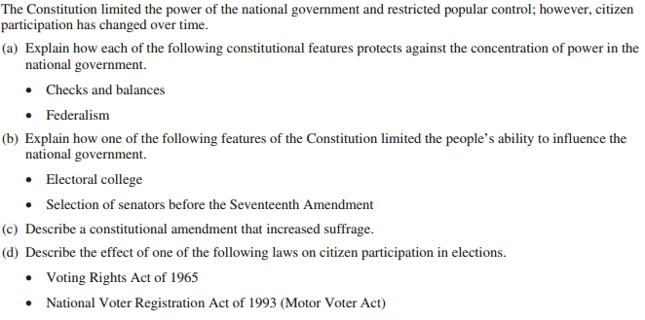
2.

